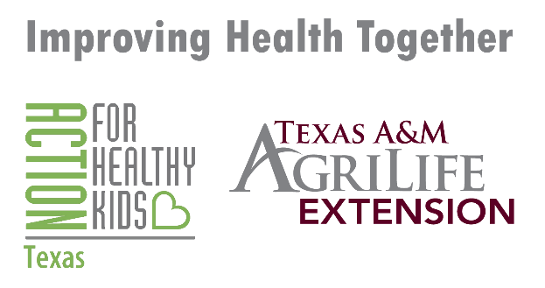

EVERY KID HEALTHY WEEK SOCIAL MEDIA PACKET-
SCHOOL EDITION
2021

Monday’s Post:
It’s Every Kid Healthy Week this week (April 26-30th)! We are encouraging schools to have fun while teaching students to eat healthy and be active! Today is Mindful Monday: Get your students practicing social emotional health and mindfulness skills to build resilience. #EveryKidHealthyWeek
If you need more resources on completing these activities, please visit: https://howdyhealth.tamu.edu/ekhw and everykidhealthyweek.org
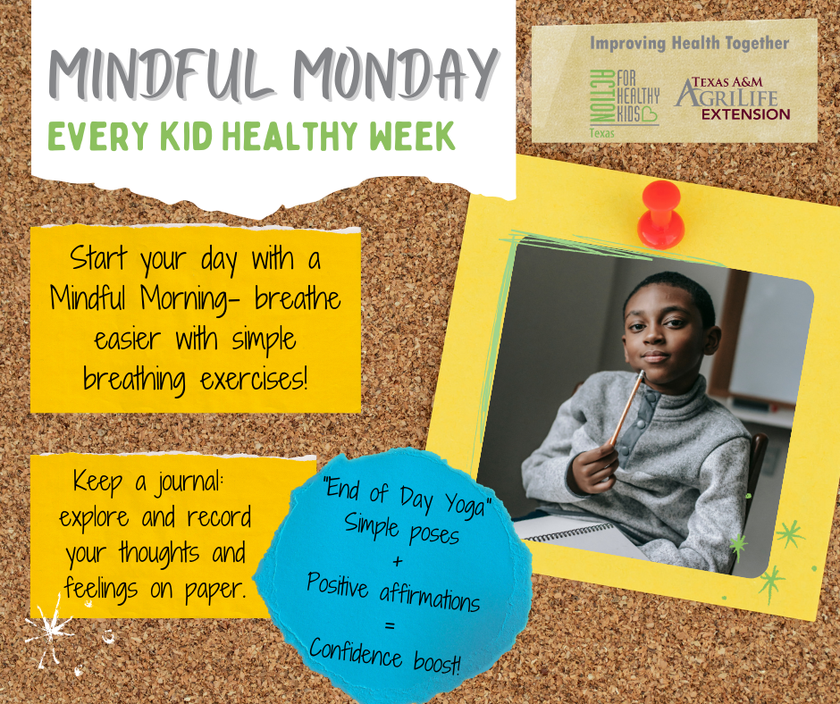

Tuesday’s Post:
It’s Every Kid Healthy Week this week (April 26-30th)! We are encouraging schools to have fun while teaching students to eat healthy and be active! Today is Tasty Tuesday: Build lifelong healthy eating habits by exposing kids to new foods, healthy cooking, and growing their own produce. #EveryKidHealthyWeek
If you need more resources on completing these activities, please visit: https://howdyhealth.tamu.edu/ekhw and everykidhealthyweek.org

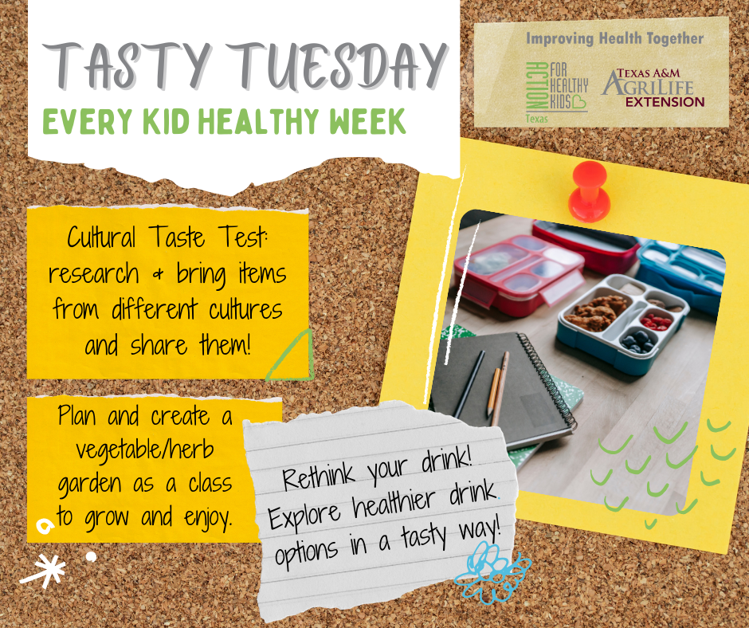

Wednesday’s Post:
It’s Every Kid Healthy Week this week (April 26-30th)! We are encouraging schools to have fun while teaching students to eat healthy and be active! Today is Wellness Wednesday: Explore with your kids or students what wellness means to them, and then develop self-care strategies. #EveryKidHealthyWeek
If you need more resources on completing these activities, please visit: https://howdyhealth.tamu.edu/ekhw and everykidhealthyweek.org

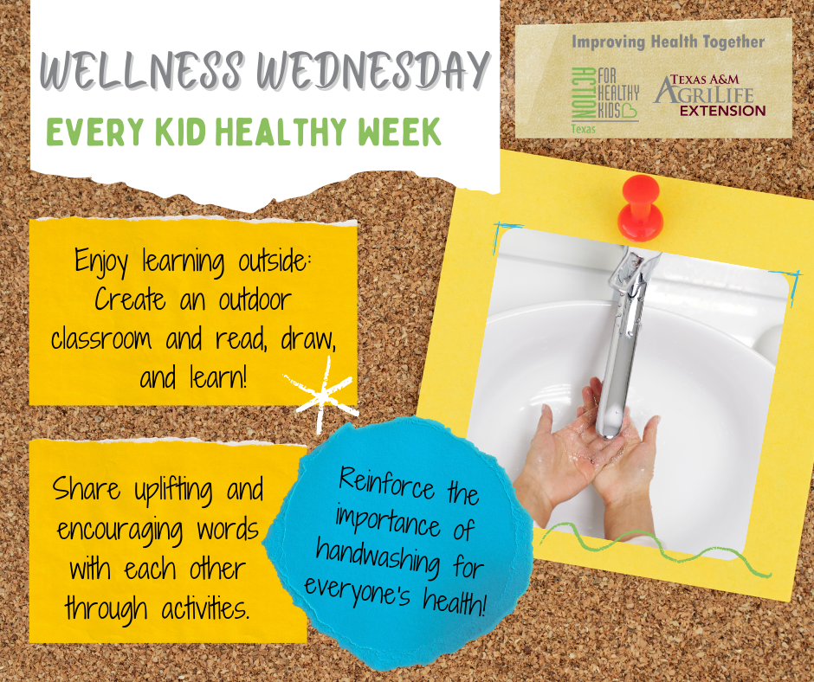

Thursday’s Post:
It’s Every Kid Healthy Week this week (April 26-30th)! We are encouraging schools to have fun while teaching students to eat healthy and be active! Today is Thoughtful Thursday: Nurture kids’ social health and positive relationships. #EveryKidHealthyWeek
If you need more resources on completing these activities, please visit: https://howdyhealth.tamu.edu/ekhw and everykidhealthyweek.org

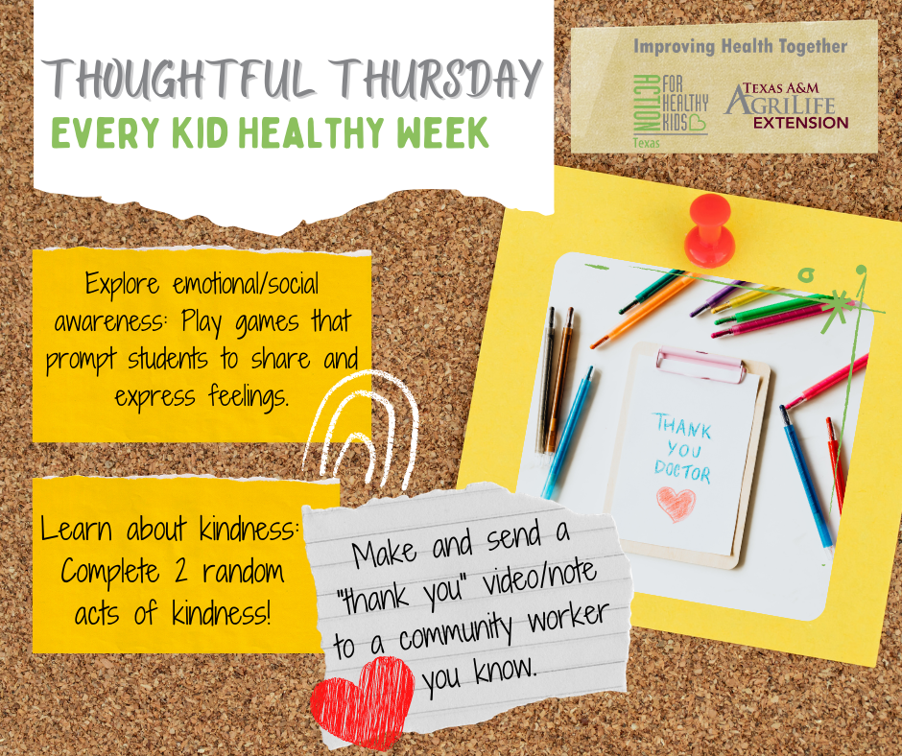

Friday’s Post:
It’s Every Kid Healthy Week this week (April 26-30th)! We are encouraging schools to have fun while teaching students to eat healthy and be active! Today is Fitness Friday: Get moving! Physical activity fuels not only the body but the mind, too. #EveryKidHealthyWeek
If you need more resources on completing these activities, please visit: https://howdyhealth.tamu.edu/ekhw and everykidhealthyweek.org

