EVERY KID HEALTHY WEEK SOCIAL MEDIA PACKET-
HOME EDITION
2021

Monday’s Post:
It’s Every Kid Healthy Week this week (April 26-30th)! We are encouraging families to have fun while staying healthy and active at home! Today is Mindful Monday: Get your kids practicing social emotional health and mindfulness skills to build resilience. #EveryKidHealthyWeek
If you need more resources on completing these activities, please visit: https://howdyhealth.tamu.edu/ekhw and everykidhealthyweek.org

Tuesday’s Post:
It’s Every Kid Healthy Week this week (April 26-30th)! We are encouraging families to have fun while staying healthy and active at home! Today is Tasty Tuesday: Build lifelong healthy eating habits by exposing kids to new foods, healthy cooking, and growing their own produce. #EveryKidHealthyWeek
If you need more resources on completing these activities, please visit: https://howdyhealth.tamu.edu/ekhw and everykidhealthyweek.org

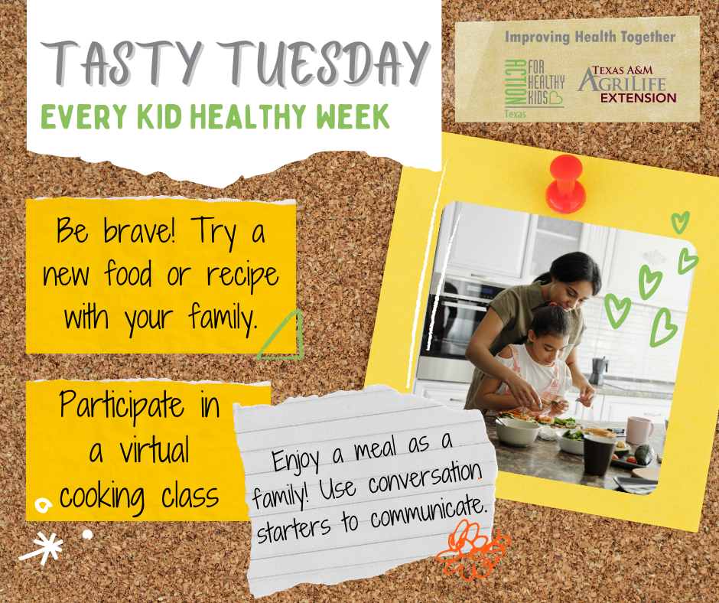

Wednesday’s Post:
It’s Every Kid Healthy Week this week (April 26-30th)! We are encouraging families to have fun while staying healthy and active at home! Today is Wellness Wednesday: Explore with your kids or students what wellness means to them, and then develop self-care strategies. #EveryKidHealthyWeek
If you need more resources on completing these activities, please visit: https://howdyhealth.tamu.edu/ekhw and everykidhealthyweek.org

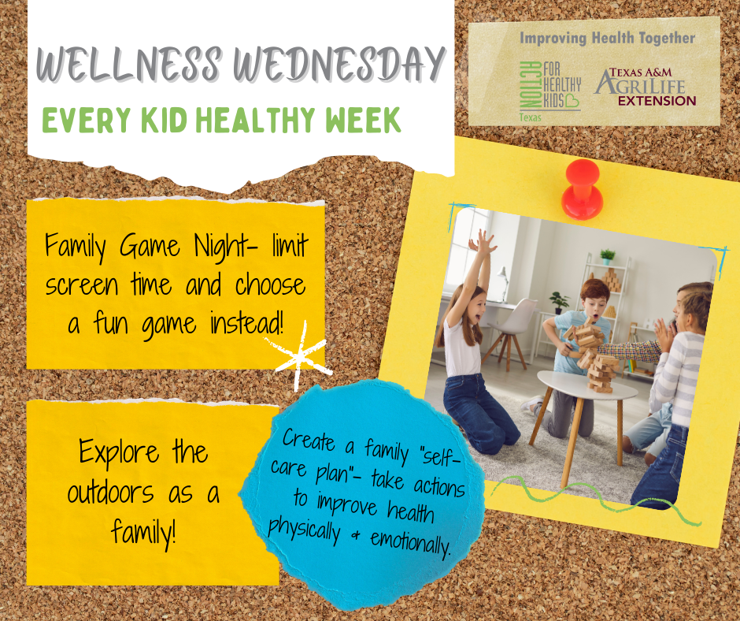

Thursday’s Post:
It’s Every Kid Healthy Week this week (April 26-30th)! We are encouraging families to have fun while staying healthy and active at home! Today is Thoughtful Thursday: Nurture kids’ social health and positive relationships. #EveryKidHealthyWeek
If you need more resources on completing these activities, please visit: https://howdyhealth.tamu.edu/ekhw and everykidhealthyweek.org

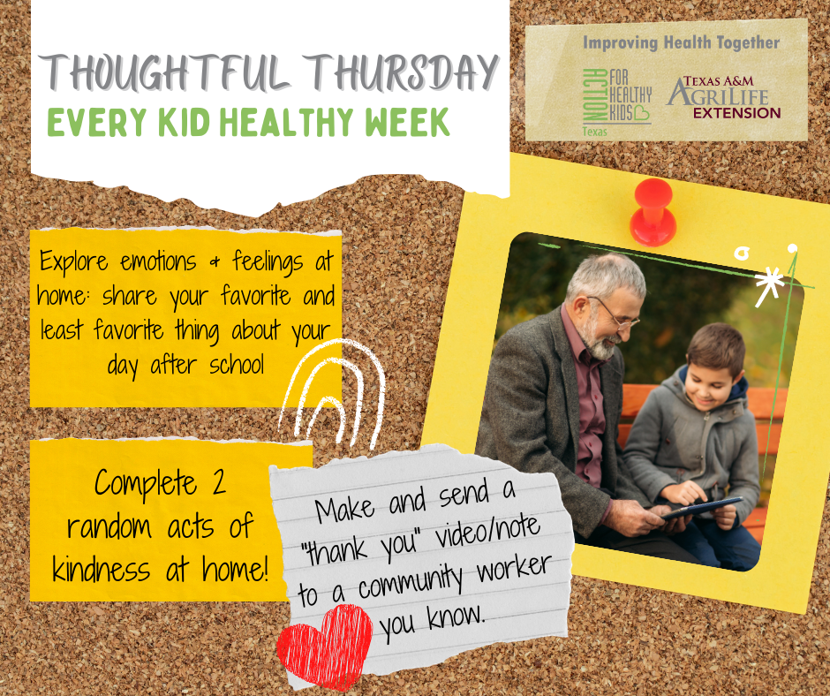

Friday’s Post:
It’s Every Kid Healthy Week this week (April 26-30th)! We are encouraging families to have fun while staying healthy and active at home! Today is Fitness Friday: Get moving! Physical activity fuels not only the body but the mind, too. #EveryKidHealthyWeek
If you need more resources on completing these activities, please visit: https://howdyhealth.tamu.edu/ekhw and everykidhealthyweek.org

