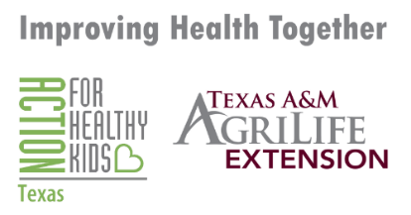
Radio Spot
For Immediate Release

Celebrate Every Kid Healthy Week at Home or at School
Every Kid Healthy™ Week is an annual observance created to celebrate school health and wellness achievements during this year, April 21-25, 2025. This year, we are celebrating Every Kid Healthy Week at home and at school! We are encouraging families and schools to be engaged this week with scheduled activities, both at school and at home, to complete and have fun while staying healthy! Each day of the week shines a spotlight on the great actions families and schools are taking to improve the health and wellness of their kids and the link between nutrition, physical activity, mental health and learning – because healthy kids are better prepared to learn and thrive! Texas A&M AgriLife Extension Service has created activities for each day. Please check out our website for more information: howdyhealth.tamu.edu/ekhw {or place your facebook page or website}

