**News Release** 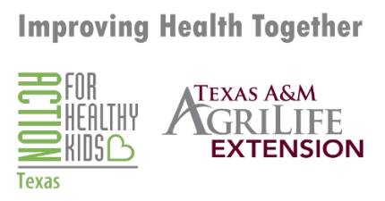

**For Immediate Release**

**Celebrate Every Kid Healthy Week at Home or at School**

Every Kid Healthy™ Week is an annual observance created in 2013 to celebrate school health and wellness achievements. Recognized on the calendar of National Health Observances and observed the last full week of April each year (April 21-25, 2025), each day of the week shines a spotlight on the great actions schools and families are taking to improve the health and wellness of their kids and the link between nutrition, physical activity, mental health, and learning – because healthy kids are better prepared to learn and thrive! We are encouraging families to continue this week with scheduled activities to complete and have fun while staying healthy and staying at home, but also provide schools with activities to do with their students safely!

That is why Texas A&M AgriLife Extension Family and Community Health Educator ____________________, ___ County reminds everyone that it is so very important to keep your family members and students healthy during this time which includes all health.

Here are the activities planned for Every Kid Healthy Week 2025:

o Mindfulness Monday: Get your kids or students practicing social emotional health and mindfulness skills to build resilience.

o Tasty Tuesday: Build lifelong healthy eating habits by exposing kids to new foods, healthy cooking, and growing their own produce.

o Wellness Wednesday: Get moving! Physical activity fuels not only the body but the mind, too.

o Thoughtful Thursday: Create a school or home culture that celebrates diversity and works progressively towards creating a more equitable learning opportunity.

o Family Friday: Bring families and schools together to support child health at school and home.

If you need more resources on completing these activities, please visit our sites: <http://howdyhealth.tamu.edu/ekhw> and <https://www.actionforhealthykids.org/get-involved/every-kid-healthy-week/>

*The members of Texas A&M AgriLife will provide equal opportunities in programs and activities, education, and employment to all persons regardless of race, color, sex, religion, national origin, age, disability, genetic information, veteran status, sexual orientation or gender identity and will strive to achieve full and equal employment opportunity throughout Texas A&M AgriLife.*